PE  Gymnastics  Mindful minutes  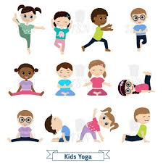 | ENGLISH  This week children will write a letter about themselves.  HANDWRITING  To continue to write words focusing on flicks, getting ready to join.  PHONICS  Daily Phonics Sessions.  READING  Daily Story Sessions & Learn a Poem.  Remember to bring in reading books / Reading cards and diaries every day. Please sign the diary when you have heard your child/ren read.  Super Sonic Phonics Sheets linked to their Phonics session (sent home on Friday) | 2.2.26  We will continue to focus on our school Behaviour Expectations & Values.  We will be reading:  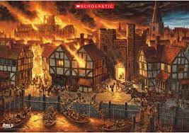  The Great Fire of London Non-Fiction & Stories | MATHS  Subtraction Calculation stories  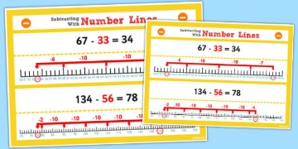 | MUSIC  A focus on singing expressively, playing tuned musical instruments, creative composing, responding to pitch changes and playing, creating and performing rhythmic patterns.  
SCIENCE  We will be looking at Materials and bath bombs  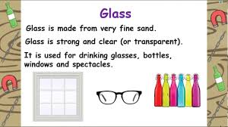 |  |  | HISTORY / ART/ COMPUTING  History comparison between 1666 and now.  Art to continue to work on fiery skies using famous artists paintings as inspiration.  Children to perfect their drag and drop skills by creating a scene higlighting their knowledge of the Great Fire of London, whilst adding text too.  GEOGRAPHY  Map of London 1666  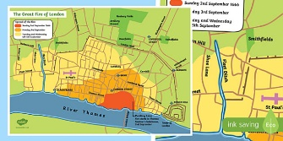
PSHE  Behaviour Expectations & Values  Reflection  Circle Time  Good Manners Banners   |  | Homework    New homework was issued on 22/1/26 on Science: Materials and is due in on 3.2.26  There will be no homework set until after the half term so children can practise reading & spelling of words at home. | FINE & GROSS MOTOR  Funky Fingers  Crossing the mid-line.  Further developing of cutting skills.  