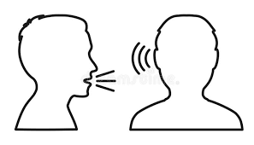
What We Are Learning Autumn 1 Week 6
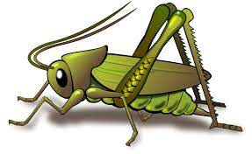
Value of the Week: Respect

Activities based on the interests of the children….
We are learning about the JHSW Values and Behaviour Expectations. We have already thought about being the best that we can be, belonging, perseverance, collaboration and good manners.  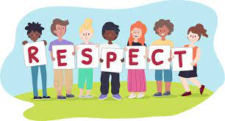  This week we will be thinking about Respect – We will be learning about the concept of treating others kindly and taking care and noticing feelings, wishes or rights of others.  Our behaviour expectation for this week is Do Listen. We will be continuing to encourage good listening skills in various ways including through group listening games such as ‘Simon Says’ and ‘Bananas for Dinner.’  We will also be continuing to learn about how to look after our classroom and each other, to work hard, to be kind and helpful and to be polite and gentle. | We will be listening to stories, rhymes and fairy tales.  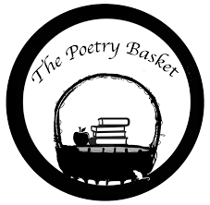  We are now onto learning our third poem. See if your child can recite the two poems that we have already learnt. They are called Chop Chop and Wise Old Owl.  Our Poetry Basket Poem this week is:  Falling Apples  Here is the tree with its leaves so green.  Here are the apples that hang in between.  When the wind blows, the apples will fall.  And this is the basket to catch them all.  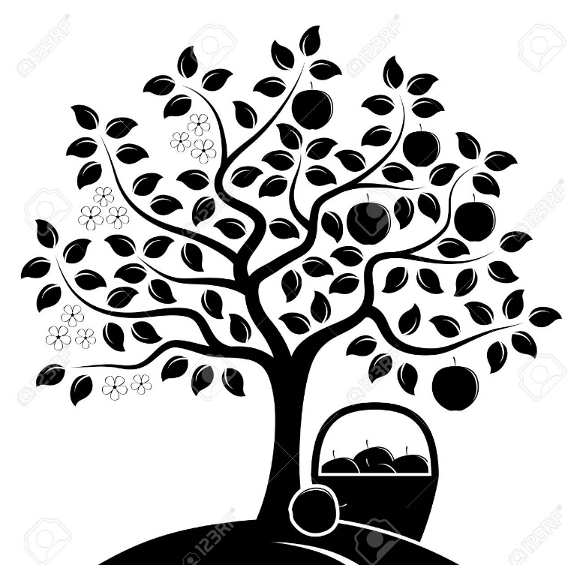 | This week our core texts are ‘I don’t want to have a bath!’ by Julia Sykes and ‘Little Elephant Listens’ by Michael Dahl. Both of these stories support our learning of the school value Respect and of our school behaviour expectation of Do Listen.  We will also continue to read familiar stories from our classroom.  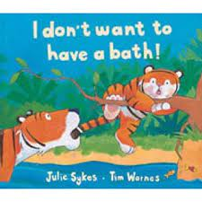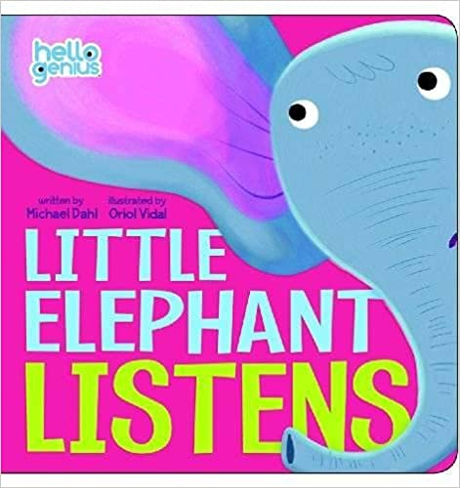  We will be singing the Nursery Rhyme “Hickory Dickory Dock”.  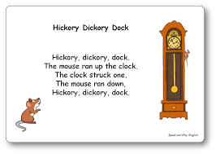
We have been learning different joining techniques in Creative eg. using stick glue and runny PVA glue. We are persevering with using the masking tape and sellotape dispensers.  This week we will be starting to think more about Autumn. We will be learning how to make leaf rubbings.  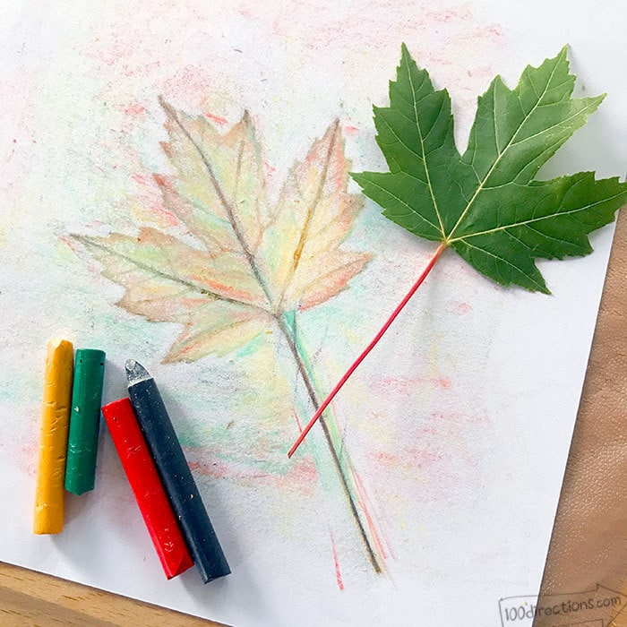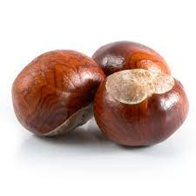  Please could you collect conkers for our Nature Kitchen and Nature Nook when you are out and about on your walk. Thank you. | This week our Number Rhyme is 3 Blind Mice  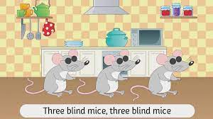  We will continue to subitise groups of objects (0-3). We will practice trying to say how many things we can see without counting.  “What do you see? How do you see it?” We will be encouraging the children to represent their Maths by mark making. | We are developing our gross motor skills with our ‘Squiggle while you Wiggle’ dance. We will be practising our mark making whilst we play by writing recipes, making shopping lists or writing telephone messages.  We will also be continuing to make different marks outside using large up/down movements whilst using the water brushes, chalks sand, and in the air with noodles and scarves.  We will be practising the pre writing pattern I and ----.  We have noticed the leaves falling in our outside area and are developing gross motor skills with sweeping.

