
Spring 1 : Week 6
Question of the Week: How do you celebrate your birthday?
Activities based on the interests of the children….
This week’s NELI story is “Don’t Wake Up Tiger” by Britta Teckentrup  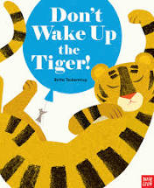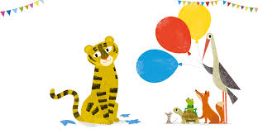  We will be developing our communication and language with special words throughout the week. We will learn about tigers, floating and sinking and there will pretend birthday parties with plenty of opportunities to write recipes, menus and shopping lists.  We would love to hear if your child tells you about the new words that they have learnt. |   Our Poetry Basket Poem this week is…  A Little House  I’m going to build a little house,  With windows big and bright,  And chimneys tall with curling smoke,  drifting out of sight.  In winter when the snowflakes fall,  Or when I hear a storm,  I’ll go and sit in my little house,  Where I’ll be snug and warm. | Conversations starters: Would you rather invite the tiger or frog to your birthday party? Why? Answer in sentences …I would rather invite the …. because ……  We will be singing the Nursery Rhyme Hickory Dickory Dock    This week our Number Rhyme is  5 Little Ducks  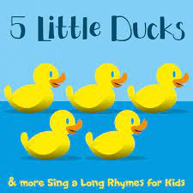
We will be using our number sense to count in order using 1:1 correspondence, saying how many there is in total.  | In Creative we will be following our interests using and applying skills learnt so far in Crickets.    This week is Discovery week. We will be engaging in special activities. | 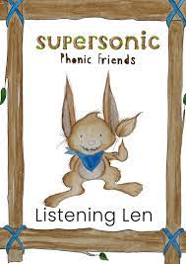  This week we will be continue to develop understanding of Alliteration, Rhyme and Voice sounds. We are listening carefully to sounds and beginning to distinguish between the initial sounds for Alliteration and the end sounds for Rhyme.  Ideas for phonic activities at home:  Play I Spy. “I spy with my little eye something beginning with… and give the sound of the first letter, for example ‘s’. Show your child a tray of ‘I spy’ items. (These can be anything from around the home such as a dinosaur, cup, ball, hat etc...) Then ask: Which one can it be?

