Question of the Week – What happened to the dinosaurs? WB: 15.1.2024

We will be learning the sounds and spellings for the sounds y, z, zz, qu.  We will also be focusing on our Tricky Tess words:  he, she, we, be, me  and our high frequency word  will  We will be developing our reading memory to help us read with speed. | Brrr  It has gotten really cold recently and we are asking for all children to bring in a warm coat, hat, scarf and gloves to keep them cosy and warm outside.  Please ensure they are all labelled.  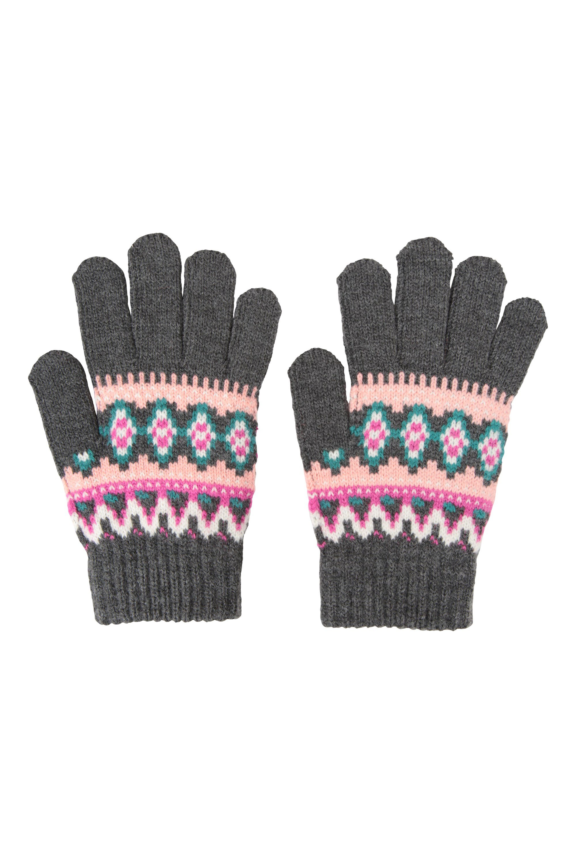 | Maths  In maths this week, we are learning to measure dinosaur footprints and we will be discussing which is the longest and the shortest.  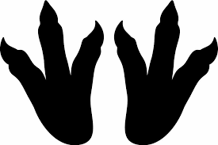  We will also be continuing to recognise numbers to five and mathcing quantities to these.  1, 2, 3, 4, 5
Understanding the World  We will be learning about how dinosaurs became extinct and engaging in a science meteriote investigation.  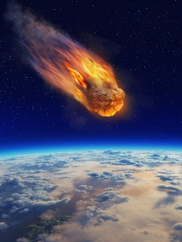 | Our topic is Explorer, Explorer  Dinosaurs  What happened to the dinosaurs?  We will be reading lots of dinosaur stories including  Dinosaurs and all that Rubbish and looking at information books about dinosaurs and extinction theories.  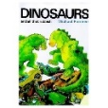 | Topic  We will be using junk modelling and the different joining skills that we have been taught to make different 3D models. If you have any tubes, cardboard boxes etc we would love them! Thank you.  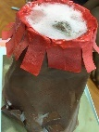 | Reminders  Please ensure your child is reading and writing tricky words and high frequency words every day. It is really important they are confident with these.  Thank you.

