Question of the Week: What are some of London’s most famous traditions and celebrations? WB: 8.6.25
  In Phonics we will be revisiting ccvcc words for example splash, splat, split as well as chunking polysyllabic words such as treetop, sandpit, picnic | In Handwriting, we will be revisiting some of the trickier letters to consolidate our learning. We will be practising the ditties and pencil strokes.  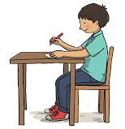 |   In Writing, we will be writing a recount of that the Gingerbread Man saw and visited when he was in London.    First, I saw Big Ben.  Then, I got on a big,  red bus……. | Maths  In maths, we will be consolidating learning on subitising, doubling, odd and even and number bonds to 10.  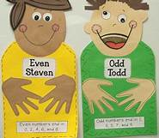
Curious Questions  Would you dare to kiss a frog?  (But what if it would turn into a  prince  or princess?)  Would you rather be a king or  a clown?  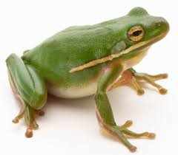 | 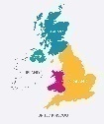  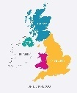  Our topic is Why is Our World Wonderful?  This week we will be learning about London’s most famous traditions and celebrations. We will be reading the following stories to support our learning.  