WB: 26.09.2022
Value: Good Manners Question of the Week: What can we use our hands and sense of touch for? Expectation; Do be polite & gentle

We will be singing number songs and rhymes, such as 3 little ducks, 5 little monkeys jumping on the bed, and 5 little men in a flying saucer.  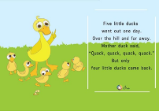 | 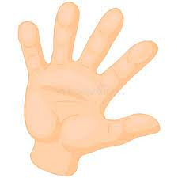  We will be learning about our sense of touch and what we can feel. We will be exploring different textures and materials to compare how they feel, and describing our experiences. |  | 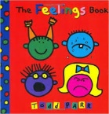  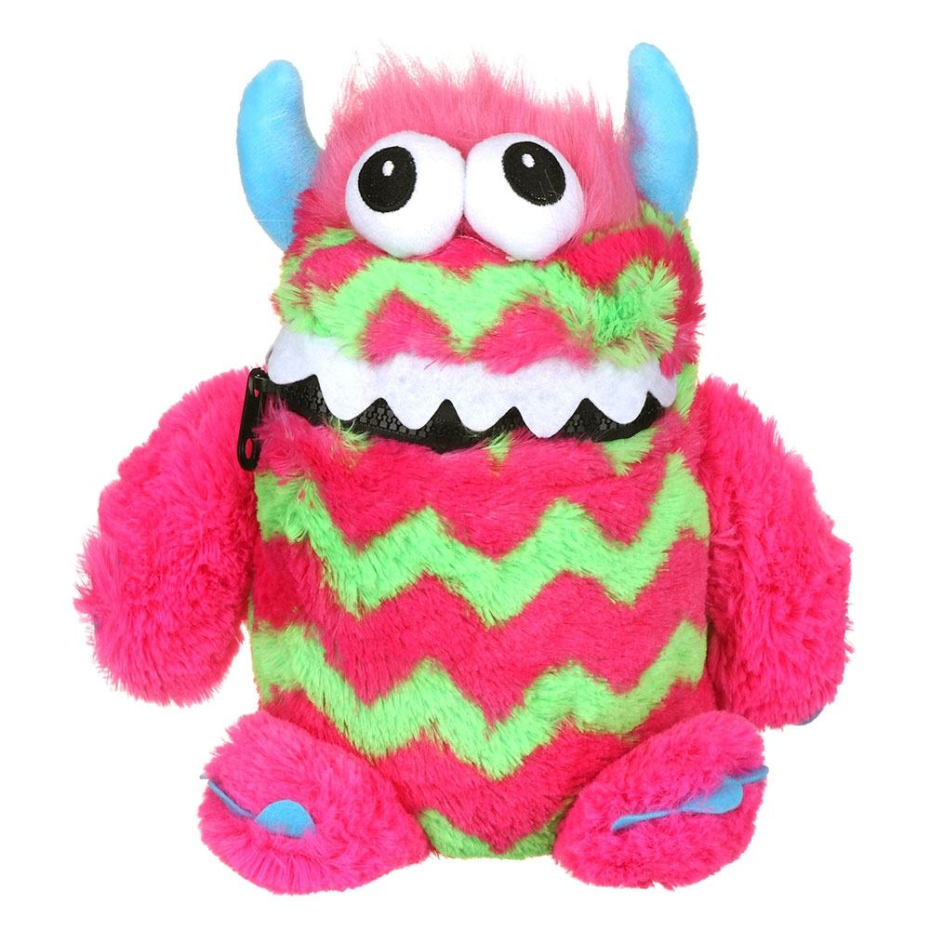  We will be thinking about the emotions angry and calm, and how we calm down when we get angry. We will be discussing the feeling of worry, and using our worry monsters class. |  | Phonics  Please find a link for a game to play at home.  https://www.topmarks.co.uk/phonics/balloon-phonics-cvc-gameIn  In Supersonic Phonic Friends we will be learningthe spelling for the sounds g, o, c and k.
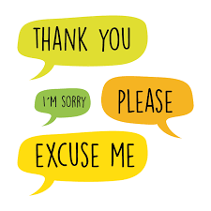  Our focus this week is: Good Manners  To treat others with courtesy and politeness and behave well towards them  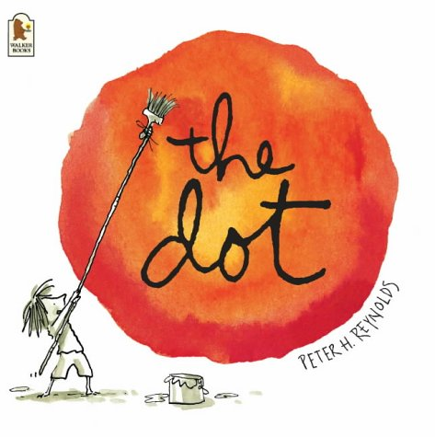  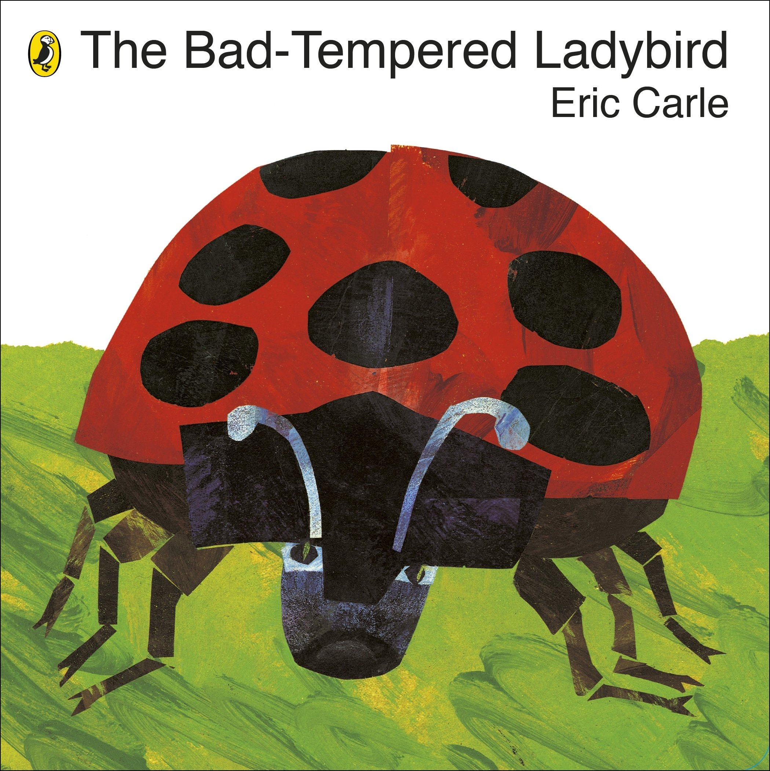  We will be reading;  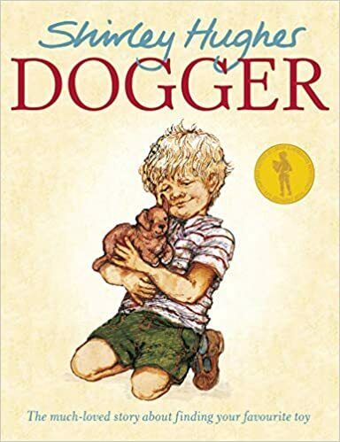  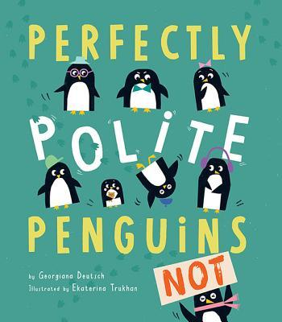 |  | In writing we will be continuing to practice pre writing patterns and mark making.  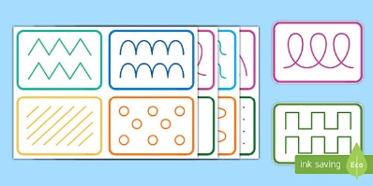 |  | This week’s Poerty Basket Poem;    Leaves are Falling, Leaves are falling  Falling on my nose,  Leaves are falling, Leaves are falling,  Falling on my toes  Leaves are falling, Leaves are falling,  Falling on my head  Leaves are falling, Leaves are fallings  Yellow, Orange, Red
We will be thinking  about the expectations  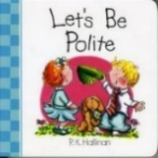  ‘Do be polite’. ‘Do be gentle’. | Home Learning Tips and Hints  Playing I-spy with initial sounds (sss for snake) will help with practicing  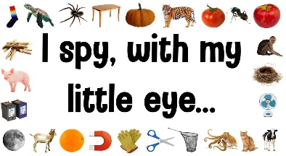  children’s listening skills. |  |  |  | Harvest Festival.  We look forward to welcoming you to our Harvest performance on Wednesday 27th September at 9.30am.  - 