English  This week we will be focusing on writing our own tales tool kit, including full stops, capital letters, adjectives and using ‘and’ in our sentences. | Maths  We will be looking at 3D shapes. | PE  Our focus in PE in this half term will be multi-skills Please ensure your child has a full, named PE kit including joggers as we will sometimes be outside.
Music  We are learning songs for our Christmas Nativity. | Week beginning 1.12.25  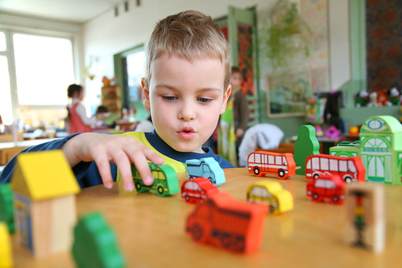 | Science  This week we are going to be looking at materials and their properties. Linking it back to our main focus of recycling.
Poetry  We will be looking at classic Poems from our “Poetry Basket”.  This half term our poems are “Emotions” |  | Art  This half term we are going to be looking at watercolours and the two artists: Van Gogh and Paul Klee.
 | PSHE  This half term we are focusing on looking at our school values and what they mean. This week we are going to be looking at respect. | History  This week we are looking at how we know if an object is old or new.
Phonics
We will be working through the choose to use sounds and tricky words.

