English  We will be writing information booklets about animals. | Maths  We will be looking at place value within 100 and solving word problems. | PE  Our focus in PE in this half term will be multi-skills Please ensure your child has a full, named PE kit including joggers as we will sometimes be outside.
Music  We will be exploring musical sounds and how they can be changed focussing on timbre, dynamics and pitch. | Week beginning 15.6.26  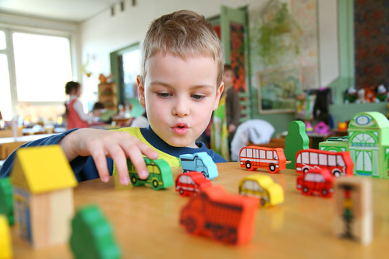 | Art  This half term our skill is sewing. We will be practicing threading a needle, and different types of stitches, towards making a final product.
Poetry  We will be looking at classic Poems from our “Poetry Basket”.  This half term our poems are “World” |  | Science  We will be revising the five animal groups
 | PSHE  Our topic this half term is all about diversity and communities. This week we will know that people can enjoy the same and different things. | History  This week we will be starting to look at different explorers and what makes someone important.
Phonics
We will be recapping the choose to use sounds and switch it mitch sounds.

