English  We will be writing our own recount and extending our learning in provision. | Maths  We will be recognising all coins and notes and know their value. | PE  Our focus in PE in this half term will be multi-skills Please ensure your child has a full, named PE kit including joggers as we will sometimes be outside.
Music  We will be exploring musical sounds and how they can be changed focussing on timbre, dynamics and pitch. | Week beginning 22.6.26  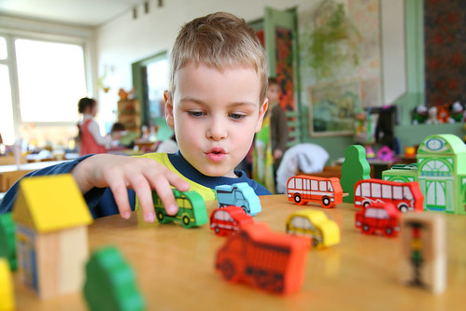 | Art  This half term our skill is sewing. We will be practicing threading a needle, and different types of stitches, towards making a final product.
Poetry  We will be looking at classic Poems from our “Poetry Basket”.  This half term our poems are “World” |  | Science  We will be visiting the zoo on Thursday 25th to support our learning about animal groups.
 | PSHE  Our topic this half term is all about diversity and communities. This week we will know that people can enjoy the same and different things. | History  This week we will be looking at who was the first explorer on the moon and why it was important.
Phonics
We will be starting spelling rules in our phonics lessons this half term.

