Autumn 1 Week 5
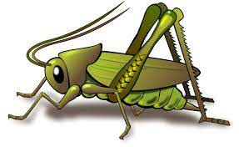
Value of the week: Respect
Activities based on the interests of the children….
Our story  This week our core texts are ‘I don’t want to have a bath!’ by Julia Sykes and ‘Little Elephant Listens’ by Michael Dahl. Both of these stories support our learning of the school value Respect and of our school behaviour expectation of Do Listen.  We will also continue to read familiar stories from our classroom.  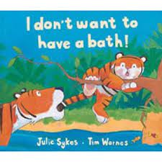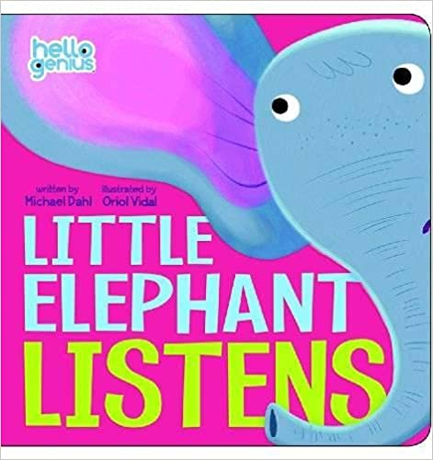 | Poetry basket  We will be listening to stories, rhymes and fairy tales.  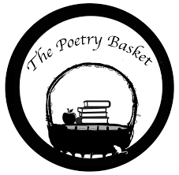  We are now onto learning our third poem. See if your child can recite the two poems that we have already learnt. They are called Chop Chop and Wise Old Owl.  Our Poetry Basket Poem this week is:  Falling Apples  Here is the tree with its leaves so green.  Here are the apples that hang in between.  When the wind blows, the apples will fall.  And this is the basket to catch them all. | Phonics  We will be continuing to use our listening ears by playing lots of games and going on walks inside and outside to see what we can hear in our environment.  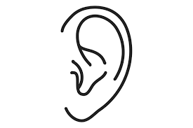
Maths  This week our Number Rhyme is 3 Blind Mice  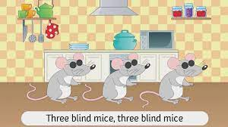  We will continue to subitise groups of objects (0-3). We will practice trying to say how many things we can see without counting.  “What do you see? How do you see it?” We will be encouraging the children to represent their Maths by mark making.  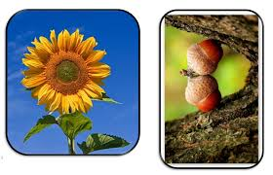 | Our value of the week  Our value this week is: Respect  Our behaviour expectation this week is: Do Listen.  We will be learning about the concept of treating others kindly and taking care and noticing feelings, wishes or rights of others.  We will be continuing to encourage good listening skills in various ways including through group listening games such as ‘Simon Says’.  We will also be continuing to learn about how to look after our classroom and each other, to work hard, to be kind and helpful and to be polite and gentle.   | Mark making  We are continuing to develop our gross motor skills with our ‘Squiggle while you Wiggle’ dance. We will be practising our mark making whilst we play.  We will also be continuing to make different marks outside using large up/down and across movements whilst using the water brushes, chalks, sand, and in the air with noodles and scarves.  We will be practising the pre writing patterns | and -------.

