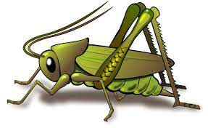
Spring 2 Week 2
Book Week & Early Year Communication week
Question of the Week: What traditional tales do you know?
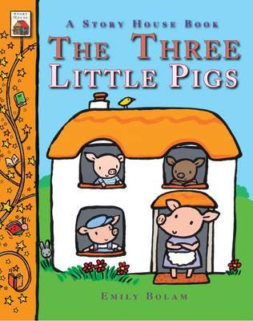  This week’s NELI story is ‘The Three Little Pigs’  We will be developing our communication and language with special words throughout the week. We will talk about the different types of houses the three little pigs built. We will be thinking about the hungry wolf and talking about what we like to eat when we are hungry.  Linked to the core text we will be reading other familiar traditional tales. Little Red Riding Hood and Goldilocks and the Three Bears.  As it is Book Week and Early Years Communication week we have some lovely live story telling activities planned and your children will have the opportunity to share books with the Wendover Junior School children. | 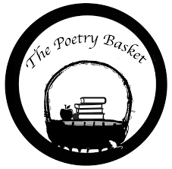  Our Poetry Basket Poem this week is:  Spring Wind  When the spring wind blows,  In her gruff and growly way,  She’s saying keep your mittens on,  I’m blowing cold today.  But when the spring wind blows,  In her soft and gentle way,  She’s saying take your jumpers off,  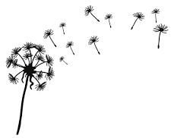  I’m blowing warm today. | We will be making our very own pig houses and decorating them in a way that represents straw, twigs or bricks.  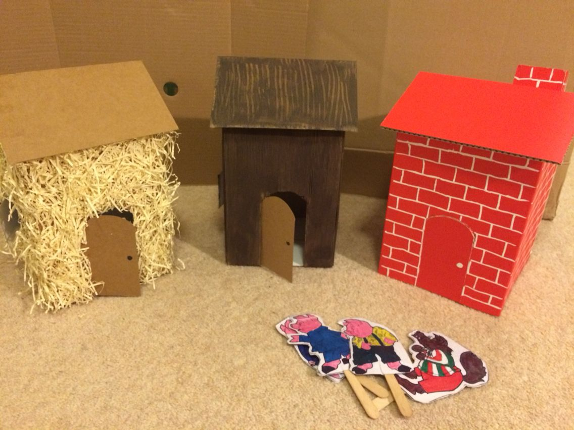  We will be story telling and acting out the story of the 3 little Pigs in sequence, aswell as making split pin pigs using our creative skills.
In number we will be comparing two groups of objects and learning the vocabulary to explain which group has ‘more’ and ‘less’.  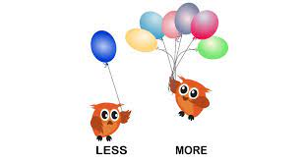 | The Nursery rhyme of the week is ‘One Potato, two potato’  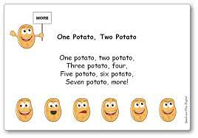  Our number rhyme this week is ‘Old MacDonald had a Farm’ | 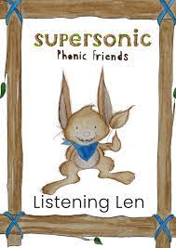  This week we will be practising ‘vocal sounds’  Ideas for phonic activities at home:  When you are out and about, ask your child about the sounds things around them make, for example “What sound does a clock make?” – tick tock, tick tock,. “What sound does a train make?” – ch, ch, ch, ch,ch, “What sound does a bee make?” - zzzzzzzzzzzzz

