Question of the Week: What are some of the UK’S most amazing and famous features and landmarks? WB: 4.6.24
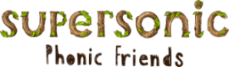  In Phonics we will be learning how to write the words  went past | In Handwriting, we will be forming Curly Cal letters within words. We will be writing the words below -  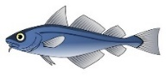  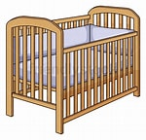  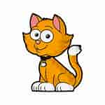  cat cot cod        cog sat sad |   In Writing, the children will be verbally recounting their Wendover Walk Trip. They will be using the time connectives to sequence their journey.  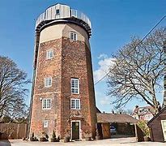 | Maths  In maths the children will be securing their subitising skills to 5 and using their knowledge to subitise quantities within larger groups.  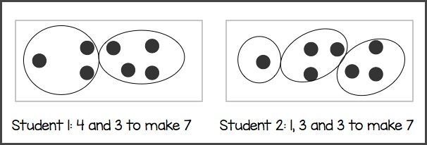
  A Little Seed  A little seed for me to sow,  A little soil for it to grow.  A little hole, a little pat,  A little wish, and that is that.  A little sun, a little shower,    A little wait, and then a flower. | 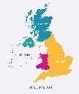  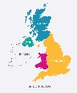  Our topic is Why is Our World Wonderful?  During Worlds Weeks we will be learning about the United Kingdom. By the end of this week, we will know that the United Kingdom is an island and that it is comprised of four countries.  We will focus on the capital city London and famous landmarks.  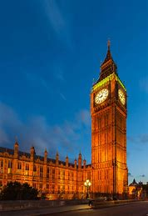  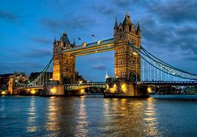  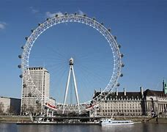 |  | Parents Hints and Tips  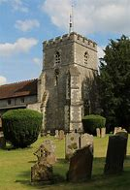    Reminder  Church Trip  Wednesday 12th June 2024  Coats & Sunhats  Please ensure children have a waterproof coat and a sunhat everyday. Please apply sun lotion if needed - dependent on the forecast.  We are outside regardless of the weather.

