WB: 9.12.24 & 16.12.24 | Value: Independence | Behaviour Expectation: Do be honest
Question of the Week: How Are Colours and Light Used In Celebrations?

WB: 9.12.24 We will be reading the story:  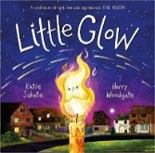  Grandma’s Fantastic Words  important special extraordinary  same ordinary common usual    Please use these words in a variety of different contexts for example, “ | . WB: 16.12.24 We will be reading the story:  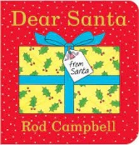    far away afar in the distance  near close | We will be weighing and exploring heavier and lighter. Are large light things/ small heavy things?  We will be exploring the differences between 2D and 3D shapes.  We will be exploring capacity – finding an appropriate container for a specific item | How to use mark making techniques and colour to portray different celebrations e.g fireworks, Diwali, Hanukah, Christmas cards  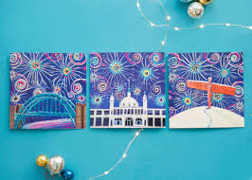  We will be designing something for a party using fabric.
Curious Conversations:
Would you like it to be Christmas everyday?

Phonics  We will continue to hear syllables in words.  We will be learning the spellings for the sounds:  ff ll ss  We will be learning to read the tricky words of and into and the high frequency word off Please see Parents Phonics Newsletter for further details | To answer the questions of the week How are colours used in celebrations?  We will be recapping on all of the festivals and celebrations that we have been learning about celebrations and can to talk about how they might be celebrated, e.g. Christmas, Advent, Diwali, Hanukah when we read Little Glow  We will be learning how Christmas is celebrated differently around the world.  We will be joining in celebrations at school and remembering what happened last year on that same day. |  | We will be continuing our learning about maps and how Santa  

