WB: 5.10.26 | Value: Independence | Behaviour Expectation: Do be honest
Question of the Week: What parts of the body are important for exploring our sense of smell?

We will be reading the story:  Only One You by Linda Kratz  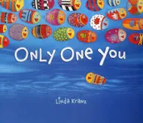  https://www.youtube.com/watch?v=QP3zX4pT8Mc&t=3s | Grandma’s Fantastic Words    pleased proud delighted  sorry ashamed  Please use these words in a variety of different contexts for example, “I felt pleased when I finished my picture.  I was proud when I scored a goal in the football game and my team cheered for me.  I was delighted when I found out we were going to the park at the weekend.  I felt sorry when I accidentally stepped on my friend's foot and hurt him.” | Squiggle While You Wiggle:  We are continuing with Squiggle Dance 4 Mmm Bop. We will learn the big movement ‘the hump’, 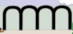 and  We will continue to draw flowers and butterflies listening to instructions first, then, next, after that, finally.   and 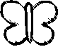  We will continue mark making with different H and B pencils. | We will learn how to draw shapes  / \ X and so that we can draw cats and houses.  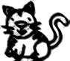
Curious Conversations:
What is your favourite smell? I agree/ I disagree/ because
Phonics  We will be learning the spellings for the sounds:  h b f l  We will be learning to read the tricky words has and his and the high frequency word had, him, back, but, big, if  Please see Parents Phonics Newsletter for further details | Our value this week is -  Independence  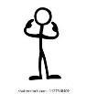  To be able to achieve or do something without the help and support of others  The children will demonstrate in a variety of ways different levels of independence throughout their learning this week including:  Our behaviour expectation this week is: Do be honest. |  | Tales Toolkit  We will be using all of the Tales Toolkit symbols to tell a story. Here is an example of the structure we will use:
  Once upon a time there was a lonely bear who lived in a deep dark forest. One day the lonely bear decided to go for a stroll along the
  But
  So
  Snip snap snover the story is over.

To answer the questions of the week What parts of the body are important for exploring our sense of smell?  .  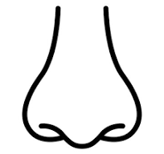 | In Maths we will continue to subitise.  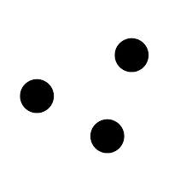  I can see 3.  I can see a 1 and a 1 and a 1.  I can see a 2 and a 1. | 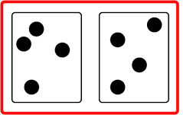  I can see 4. I can see a 3 and a 1.  I can see a 2 and a 2.
  Poetry Basket Poem  A little old lady with a tall pointy hat,  Knocked on my door with a rat-a-tat-tat,  I peered through the window,  To see who was there,  And off on her broomstick,  She flew through the air. | We are learning to show finger numbers.  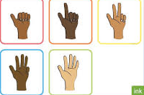 | We will be playing dice games with 5 and 10 frames.  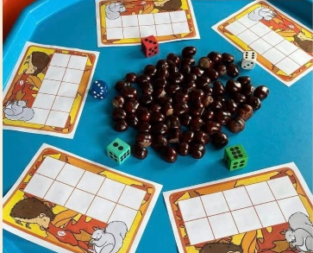
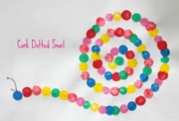  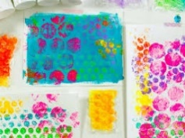  We will learn that paint can be used to print with sponges, cotton buds, fork, combs, dabbers and found objects. | We will recap on all of the joining techniques that we have learnt so far - using glue sticks, sellotape, masking tape, treasury tags and a hole punch and a stapler. We will learn how to join using a hole punch and split pins. We will learn that if we attach things using split pins, they can move.  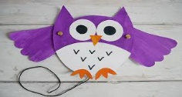  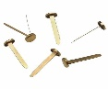 | Please share Library Book Club  

