PE  Sports Day Practise & Day / Athletics  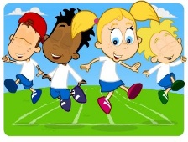  Mindful minutes | ENGLISH  Narrative: Superhero Stories  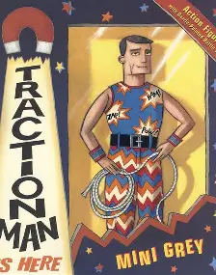  The children will listen to Superhero Stories. They will focus on the story ‘Traction Man’and innovate and create their own Superhero story.  SPAG / HFW / TW / CEW. Reading comprehension / Guided Reading - Fiction / Non-Fiction  HANDWRITING  Introduction to horizontal joins  PHONICS  Daily Phonics Sessions.  READING  Daily Story Sessions & Learn a Poem.  Remember to bring in reading books and diaries every day. Please sign the diary when you have heard your child/ren read. | 15.6.26  We will continue to focus on our school Behaviour Expectations & Values.  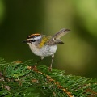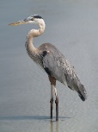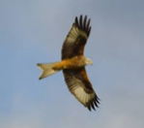  We will be reading:  Superhero stories, Non-fiction & Poems  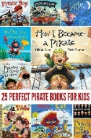  SPELLINGS  Please help the children to practise their High Frequency and Common Exception Words | MATHS  Measurement: Temperature  The children will estimate, measure, order and compare temperature using appropriate units.  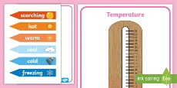  If you have time at home could you please have a go at telling the time with your child/ren, o’clock, half past, quarter past and quarter to. Plus 5 minute increments. | MUSIC  Practising our performance songs  
COMPUTING  Safe Searching, Photography and Pictograms in Computing Lessons.  They will also be using their knowledge of minibeasts and clay to create a model.  + |  |  | SCIENCE  The children will be learning about Living Things & Habitats. They will be applying their skills to whether something is living, dead or was once alive  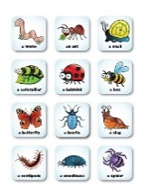
PSHE  Behaviour Expectations & Values  Reflection  Circle Time  Leaves - Reflection   |  | Homework    New homework was issued on 18.6.26 and needs to be returned on 30.6.26. The children’s homework is related to our Science Topic on Living things and habitats.  Any writing should be done in pencil and pieces should use up to 2 pages. This homework will also require a ruler. Please continue to support your child/ren during the task and encourage them to take their time and think about the presentation of their work. | FINE & GROSS MOTOR  Further developing of cutting skills.  A range of fine & gross motor skills.  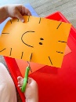  ART  Clay mini beasts  DT  DT planning farm vehicle

