WB: 29.9.25 | Value: Respect | Behaviour Expectation: Do listen
Question of the Week: What can we use our ears and sense of hearing for?

We will be reading the story:  Baby Elephant by Susan Hellard  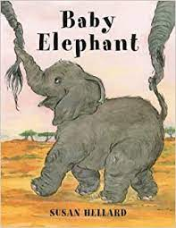 | Grandma’s Fantastic Words  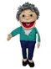  cross angry annoyed  calm peaceful  Please use these words in a variety of different contexts for example,  I felt angry when my brother pushed me.  I was annoyed when my little sister kept interrupting me.  I felt calm when I took deep breaths and listened to soft music before going to bed.  I enjoyed a peaceful afternoon watching the ducks swim. | Poetry Basket Poem  Pointy Hat  A little old lady  With a tall pointy hat  Knocked on my door with a rat-a tat-tat  I peered through the window  To see who was there and  Off on her broomstick she flew through the air!  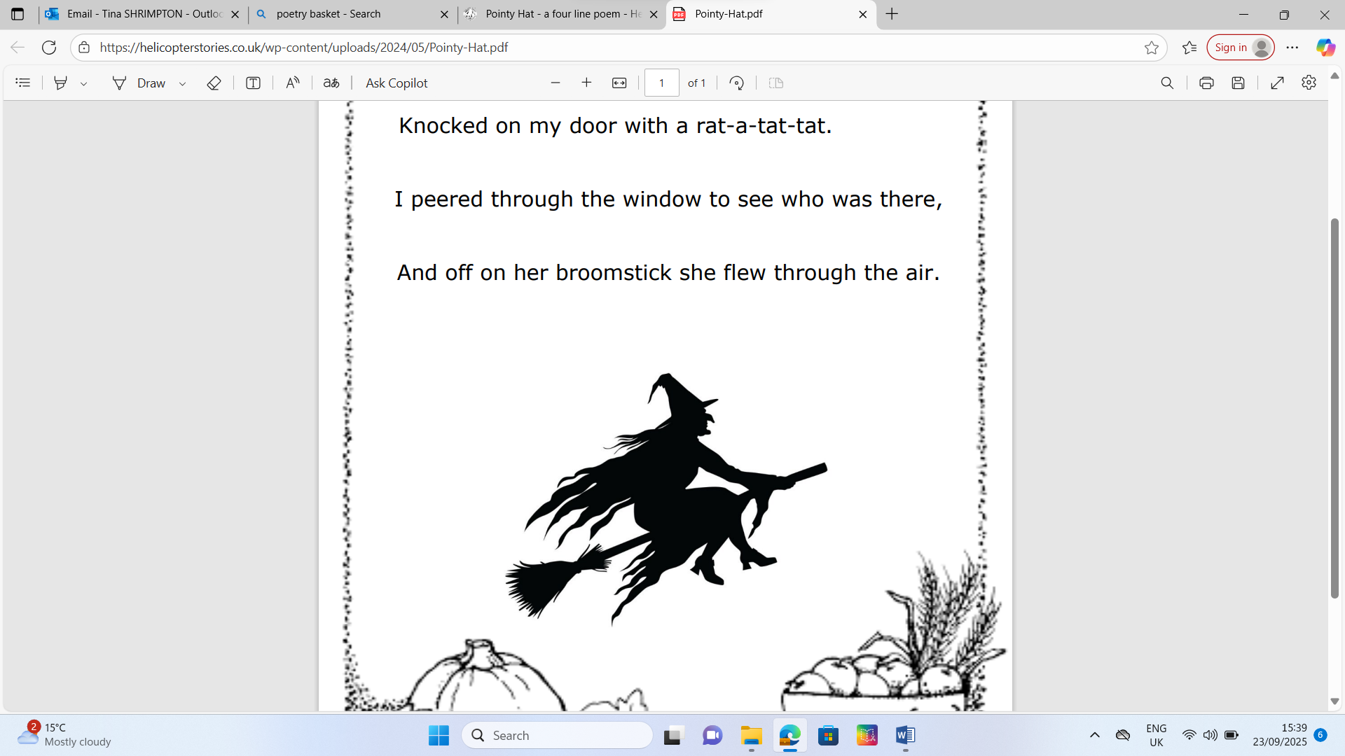 | Squiggle While You Wiggle:  We are learning Squiggle Dance 4 Mmm Bop. We will learn the big movement ‘the hump’, 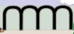 and  We will learn how to draw flowers and butterflies listening to instructions first, then, next, after that, finally.   and 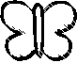  We will continue mark making with pencils, felt tips, crayons, chalk, producing an outline and filling the space with inside marks  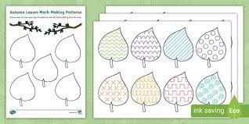
Curious Conversations:
Would you rather have a magic teacup that tells you stories or a magic blanket that3?
Phonics  We will continue to hear syllables in words.  We will be learning the spellings for the sounds:  g o c k  We will be learning to read the tricky words to and the and high frequency words on, can, got, not. Please see Parents Phonics Newsletter for further details | Our value this week is -  Respect  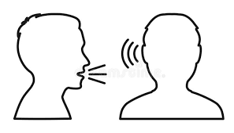  To take notice of the feelings, wishes or rights of others  The children will demonstrate in a variety of ways different levels of respect throughout their learning this week including:  Our behaviour expectation this week is: Do listen. |  | Tales Toolkit  We will be continuing to introducing Tales Toolkit symbols. This week we will focus on story endings
   | Snip snap snover, the story is over  Snip snap snout the story is out  Tap the nail, the nail bends, this is how the story ends

To answer the questions of the week What can we use our ears and sense of hearing for?,  We will read Polar Bear Polar Bear What Do You Hear? and we will explore a range of sounds and play listening games  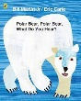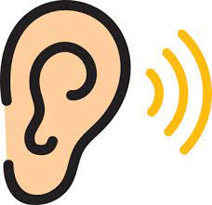 | In Maths we will be continuing to subitise, not count, asking “What can you see?” and “How can you see it?”  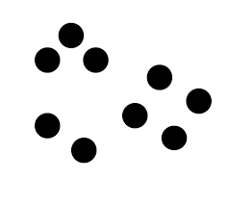 | We will being copy and extending patterns  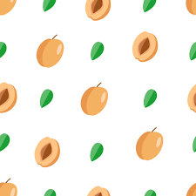  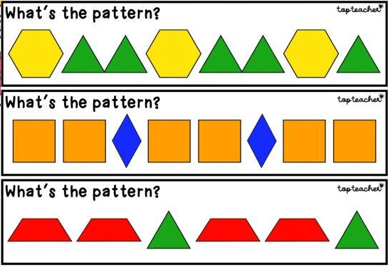
We will explore onomatopoeia words in stories  Peace at Last  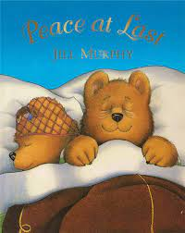  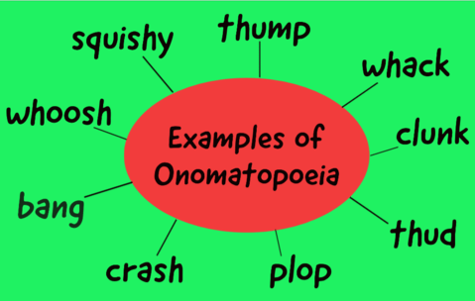 | We will recap on all of the joining techniques that we have learnt so far - using gluesticks, sellotape, masking tape, treasury tags and a hole punch and learn how to join using a stapler. We need to listen out to “hear the click.” | Please share Library Book Club  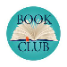
   | 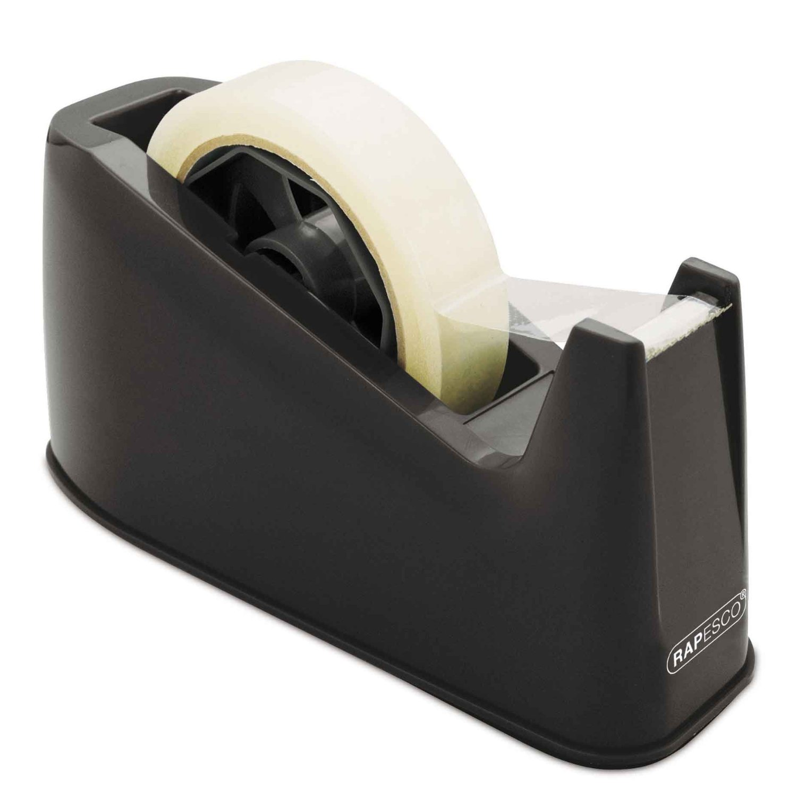 | 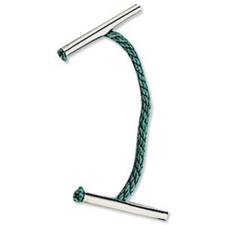 | 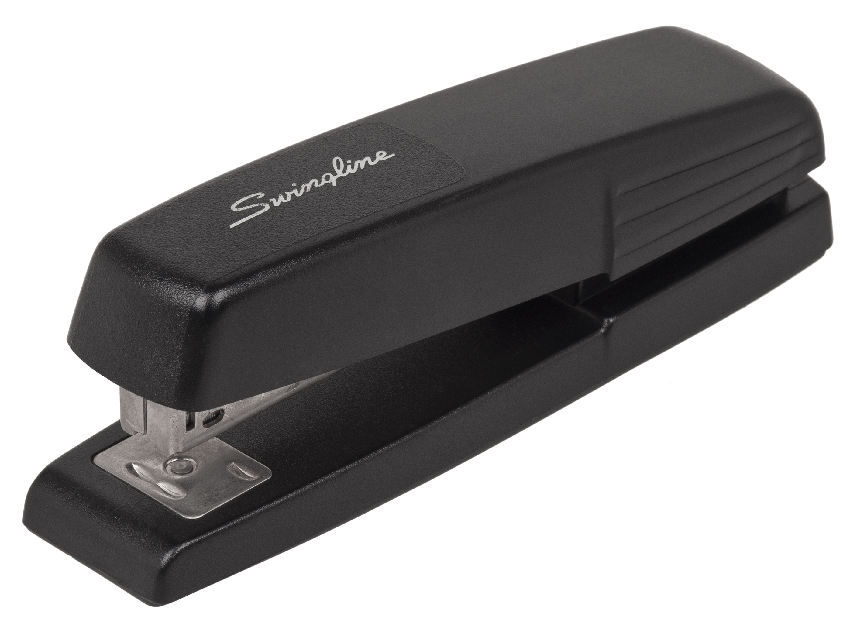
  glue | tape | treasury tags | stapler

