WB: 03.10.23
Value: Respect Expectation: Do listen Question of the Week: What can we use our ears and sense of hearing for?

We will be reading the  following stories this week: Baby Elephant, I Don’t Want To Be A Frog and All Are Welcome.  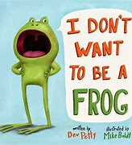  We have chosen stories that relate to this weeks expectation and value to help consolidate the children’s understanding. | We are continuing to learn about our senses. We have been on a noticing walk around the school. This week we are focusing on identifying different sounds. Can you go on a noticing and sound walk within your local environment?  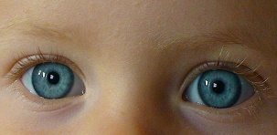 |  | In Phonics we are continuing to segment and blend words. A game to play could be Phonics Play, Phase 2, set 1 https://www.phonicsplay.co.uk/resources/phase/2/buried-treasure  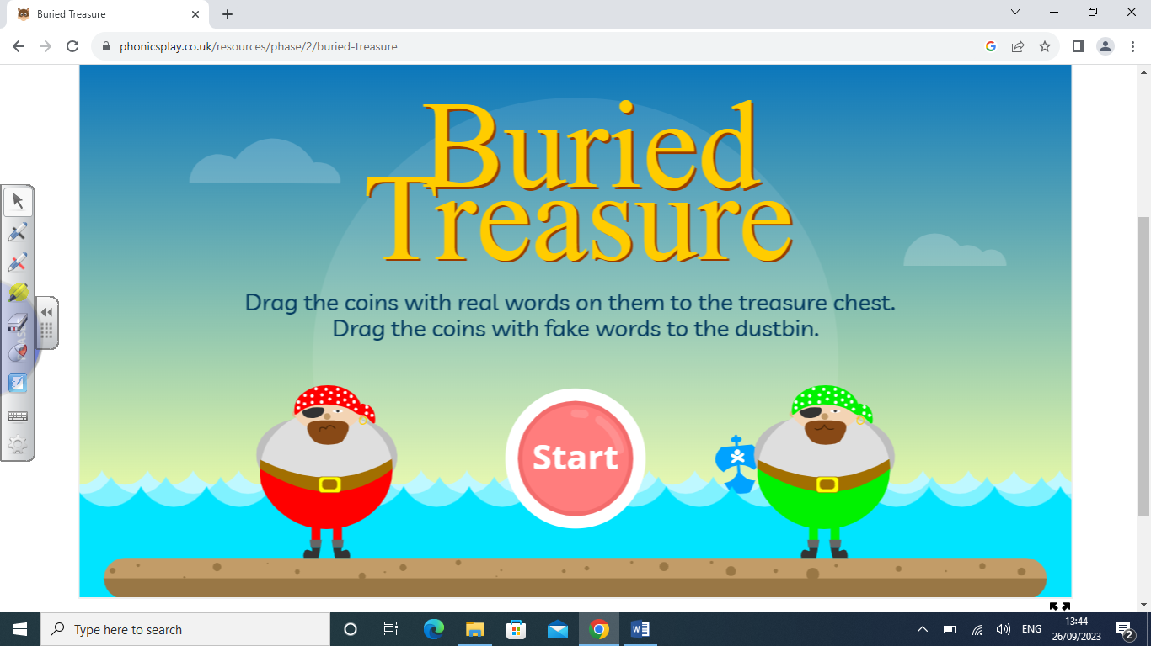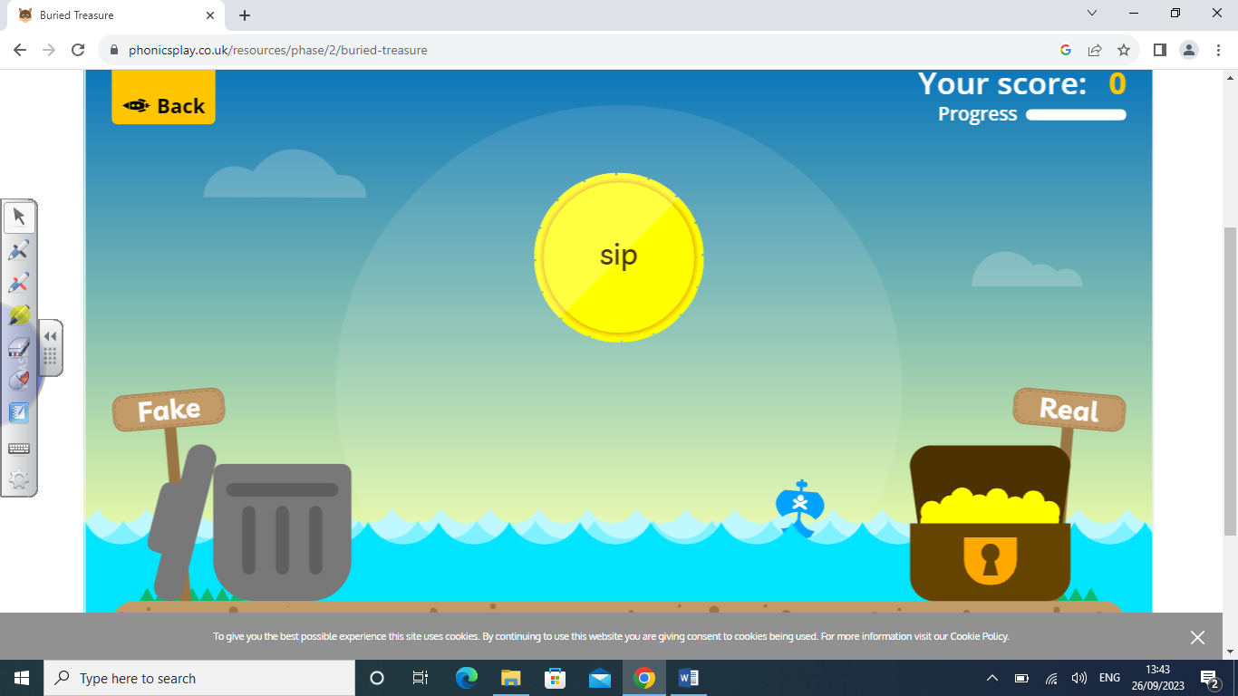  In Supersonic Phonics we are going to be learning the sounds e, u, h and r.  Tricky words learnt so far – I, is, to, the, go, no.
Our value this week is  Respect  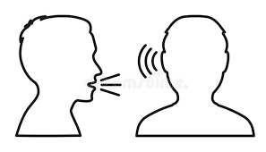  To take notice of the feelings, wishes or rights of others.  We will be thinking about our behaviour expectation – Do Listen. | PE we will be participating in team games and collaborating to achieve a set goal.    Please remember that the children have PE every Wednesday and therefore need their PE kits in school. Thank you. | In ‘Squiggly Whilst We Wiggle’ we are learning the following patterns:  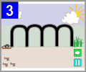  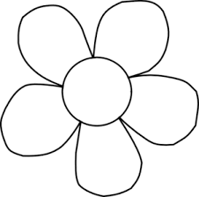  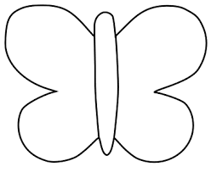 |   This week’s Poetry Basket Poem;  Leaves are Falling, Leaves are falling  Falling on my nose,  Leaves are falling, Leaves are falling,  Falling on my toes  Leaves are falling, Leaves are falling,  Falling on my head  Leaves are falling, Leaves are fallings  Yellow, Orange, Red | Home Learning Tips and Hints  Daily reading with your child will help them to establish a love of reading and enable them to develop their comprehension skills.  Grandma’s Fantastic Words  Angry – Cross, annoyed  Calm – Peaceful

