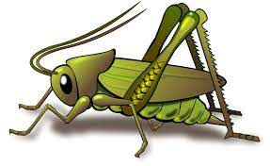
Spring 2 Week 3
Theme of the week – Dinosaurs
Activities based on the interests of the children….
This week’s story is ‘How to look after your Dinosaur’ by Jason Cockcroft  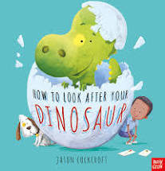  Other stories we will be reading include:  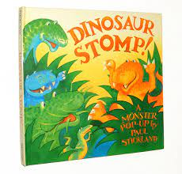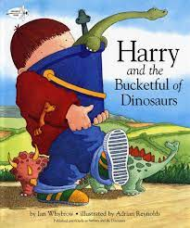 | Our poem this week is called:  Hungry Birdies  I have built a little nest, look inside, look inside.  Hungry birdies with their beaks, open wide, open wide.  And the little birdies grow, day by day by day.  ‘Till they spread their wings and fly, far away, far away.  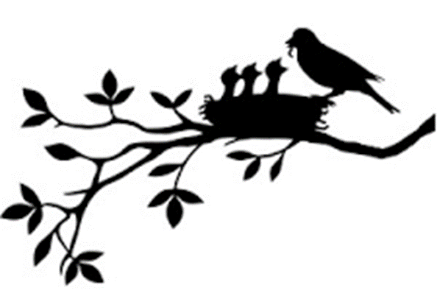 | In Maths we will be exploring how we can separate groups of 2 and 3 objects in different ways, whist beginning to recognise that the totals are the same.  We will also be counting forwards, backwards and re-ordering numbers along the number line, focussing on the numbers 0-10 and matching numerals to quantities.  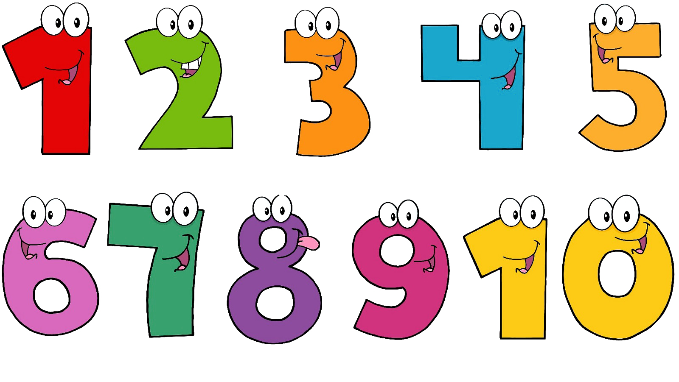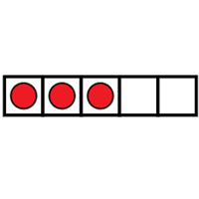  We will be exploring dinosaur sizes, shapes and colours and having a go at ordering them according to their size.
Our number rhyme this week is 1,2,3,4,5 Fish Alive  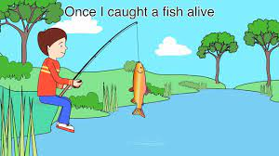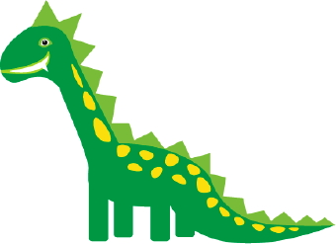  We will be keeping ourselves active by doing the ‘Dino Dance’ from CBeebies Boogie Beebies session |   This week we will be continuing to develop our ‘Phonological Awareness’ by distinguishing the differences in vocal sounds, embedding our understanding of rhyme, initial sounds and beginning to hear the individual sounds in CVC words.  ][[ | There will be lots of dinosaur themed creative opportunities this week. We will be creating dinosaur footprint pictures using the paint and the dinosaurs and we will also explore a dinosaur swamp during our outside play. If the weather allows, we will be investigating dinosaur shadows.  