Autumn 1 Week 7
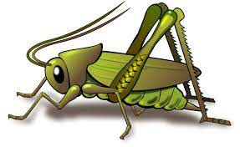
Value of the week: Reflection
Activities based on the interests of the children….
Our story  This week our core text is We’re going on a bear hunt.  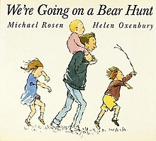  This story supports our learning of the school value Reflection. We will be reflecting on our work done so far this term by sharing the children’s learning journals together.  We will be reflecting on all of our behaviour expectations this week: do look after property, do work hard, to be kind and helpful, do be polite and do listen.  We will also continue to read familiar stories from our classroom. | Poetry basket  We will be listening to stories, rhymes and fairy tales.  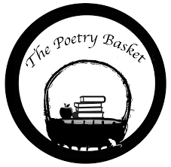  This week we will be revisiting and reciting the three poems learn this half term. They are called Chop Chop, Wise Old Owl and Falling Apples.  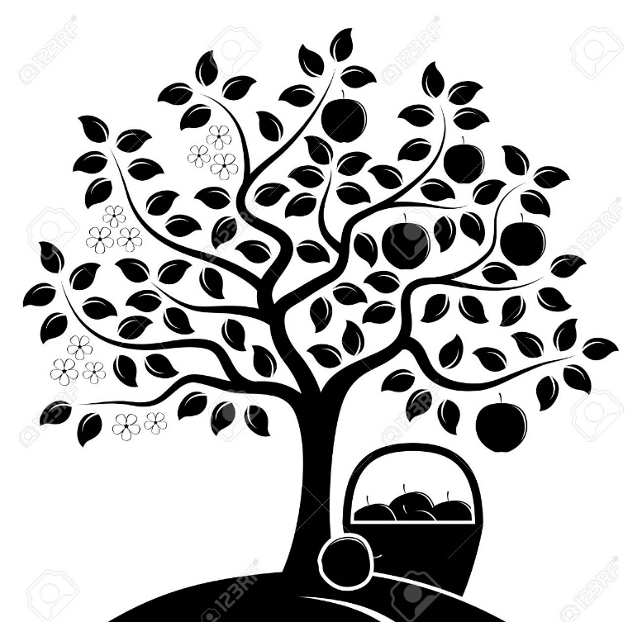  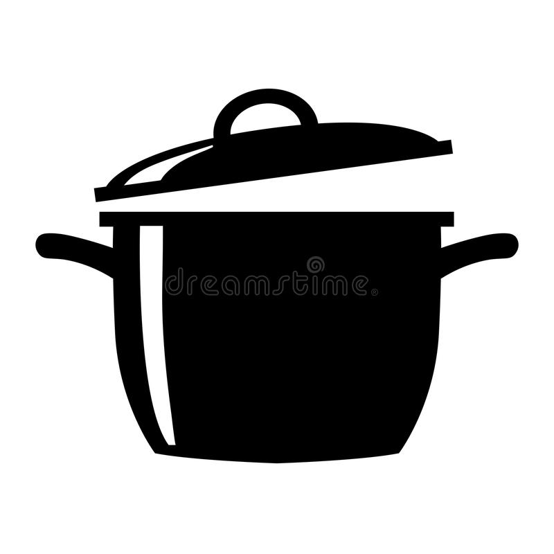  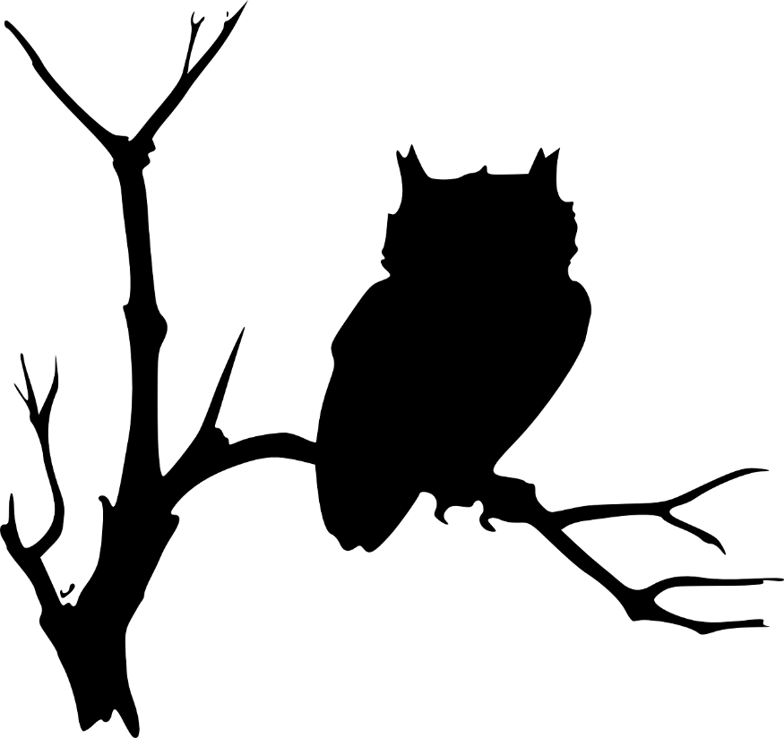  Crickets are doing so well learning these poems.  Ask your child to recite one and show you the actions. | Phonics  We will be continuing to use our listening ears by playing lots of games. This week we will be using the instruments to hear sounds and make different sounds.  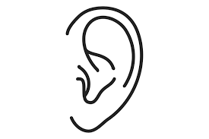
Maths  This week our Number Rhyme is ‘5 Green Bottles’  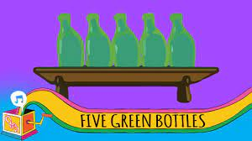  We will continue to subitise groups of objects (0-3). We will practice trying to say how many things we can see without counting.  “What do you see? How do you see it?” We will be encouraging the children to represent their Maths by mark making. | Expressive arts and design  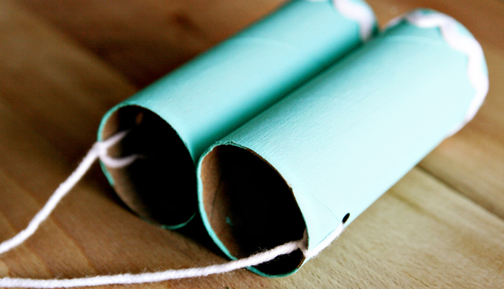  We will be acting out the story of ‘We’re going on a bear hunt.’ We will be making maps of the story and accessories we might need when we go on our own bear hunt.  If you do have any clean recyclable materials at home, such as boxes, we would really appriciate them, thank you.  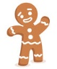 | Mark making  We are continuing to develop our gross motor skills with our ‘Squiggle while you Wiggle’ dance. We will be practising our mark making whilst we play. We will be practising the below patterns.  | ------ S O  We will also be continuing to make different marks outside using large up/down and across movements whilst using the water brushes, chalks, sand, and in the air with noodles and scarves.

