PE  May Pole Dance Practise  Mindful minutes  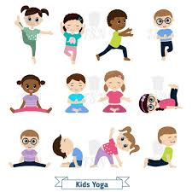 | ENGLISH  Traditional Tales  Speech bubbles for the witch and Rapunzel.  Writing sentences about the forest using co-ordinating conjunctions. Creating a story map.  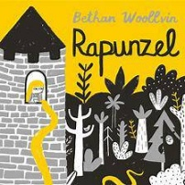  Helicopter Stories using Tales Toolkit.  SPAG / HFW / TW / CEW  HANDWRITING  Joining patterns and number thirty four, 34  PHONICS  Daily Phonics Sessions.  READING  Daily Story Sessions & Learn a Poem.  Remember to bring in reading books / diaries every day. Please sign the diary when you have heard your child/ren read.  Guided Reading children to work in partners to answer comprehension style questions | 9.3.26  We will continue to focus on our school Behaviour Expectations & Values.  We will be reading:  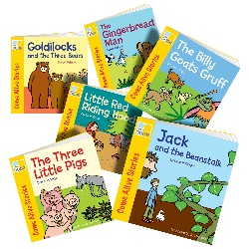  Traditional Tales  Rapunzel | MATHS  Multiplication  The children will be looking at grouping, repeated addition and recalling multiplication facts, counting in 2s, 5s and 10s.  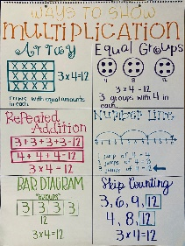 | MUSIC  A focus on singing expressively, playing tuned musical instruments, creative composing, responding to pitch changes and playing, creating and performing rhythmic patterns.  
COMPUTING  Blue bots   |  |  | HISTORY  The children are learning about Florence Nightingale. They will watch Magic Grandad and will create their own timelines about Flo’s life.  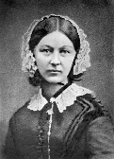  YOU MIGHT LIKE…  You could take a visit to Claydon House in Bucks. Florence was a regular visitor because her sister Parthenope lived there.  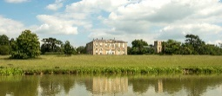
ART

Printing skills and techniques based on ‘The Wave’ by Katsushika Hokusai.


PSHE  Behaviour Expectations & Values  Reflection  Circle Time  Friendship   |  | Homework    Homework was issued on 26.2.26 on Traditional Tales and will need to be returned on 10.3.26.  New homework will be issued on 12.3.26 on Book Reviews and will need to be returned on 24.3.26 | FINE & GROSS MOTOR  Funky Fingers  Crossing the mid-line.  Further developing of cutting skills.  

