English  This week we will be writing a character description using adjectives in our sentences. We might also have had a visitor over the weekend, ask you child | Maths  We will be partitioning a 2 digit number into tens and ones. | PE  Our focus in PE in this half term will be multi-skills Please ensure your child has a full, named PE kit including joggers as we will sometimes be outside.
Music  We will be exploring musical sounds and how they can be changed focussing on timbre, dynamics and pitch. | Week beginning 2.3.26  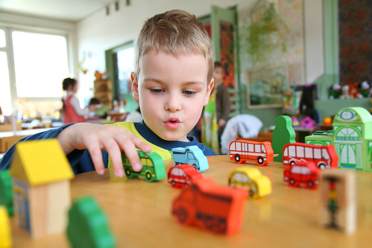 | Science  This week we will be going on a spring walk around the school. Focusing on trees and plants.
Poetry  We will be looking at classic Poems from our “Poetry Basket”.  This half term our poems are “Space” |  | Art  This half term we will be working on mixing of primary colours.
 | PSHE  This half term we are focusing on looking at feelings and how to regulate your own feelings. | Geography  We will be looking at where Wendover is located in the country and spotting all the landmarks.
Phonics
We will be working through the Switch it Mitch sounds and tricky words.

