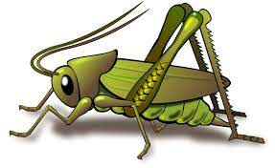
Summer 1 Week 3
Question of the Week: What does a seed need to grow?
Activities based on the interests of the children….
This week’s Story is the fairy tale of Jack and The Beanstalk  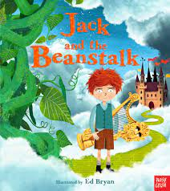  When Jack and his mother fall on hard times, they decide to sell their only cow. But Jack's mother is not impressed when her son comes home with a handful of magic beans. The beans go straight out of the window where they grow into an enormous beanstalk. At the top of the beanstalk, Jack finds a giant castle in the clouds. Inside, there are lots of stolen treasures, and there's a very angry giant. Where will Jack's adventures lead him?  Ask the children what new vocabulary they have learnt. | Poetry basket    Our Poetry Basket Poem this week is;  Pitter Patter  Pitter patter falls the rain,  On the roof and window pane.  Softly, softly it comes down,  Makes a stream that runs around.    Flowers lift their heads and say,  “A nice cool drink for us today. | Our rhymes  Our Number rhyme this week is 5 Little Beans  5 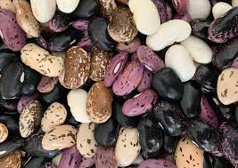  We will be singing the Nursery Rhyme Old MacDonald.  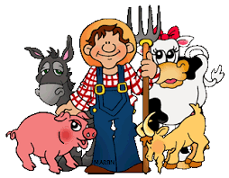  Conversation starters: Would you rather be Jack or the Giant? Would you climb the beanstalk?
Maths  We will be continuining to secure our number sense by subitising numbers to 5, placing 5 on the five frame and developing our knowledge of part/whole.    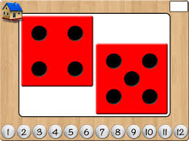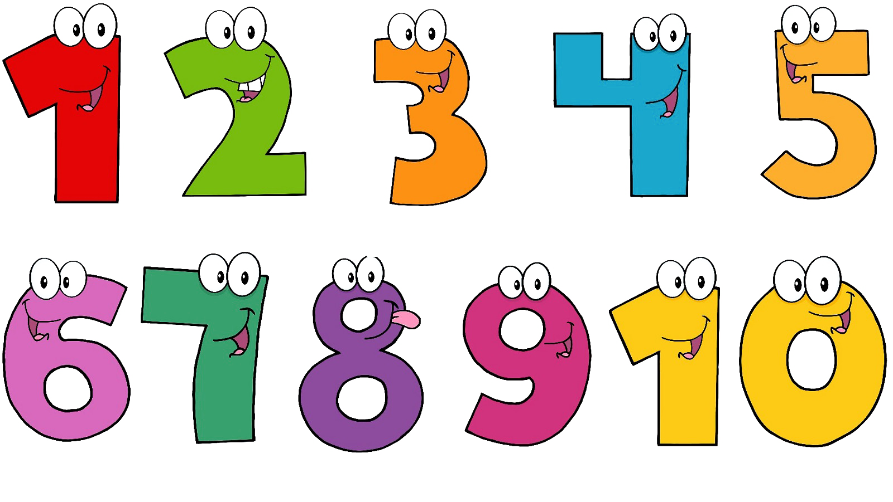 | Expressive art and design  We will be doing lots of fun activities based on the Fairy Tale ‘Jack and The Beanstalk’.  We will be doing some planting and watching them grow.  We will be using our creative skills to make a beanstalk picture and our physical skills to consruct.  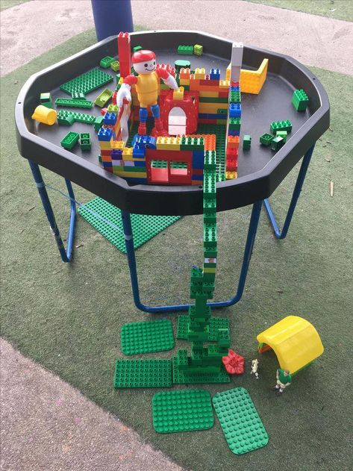 | Phonics  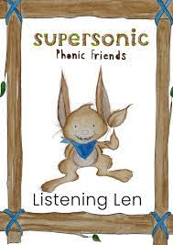  We will be embedding our phonological knowledge learnt so far. We will be doing lots of oral blending and playing fun phonics games.  