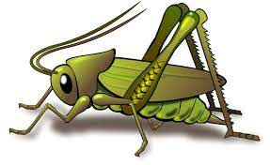
What We Are Learning: Autumn 1 Week 3
Value of the Week: Perseverance 
Activities based on the interests of the children….
We are learning about the JHSW Values and Behaviour Expectations. We have already thought about being the best that we can be and belonging by being a happy and important part of JHSW.  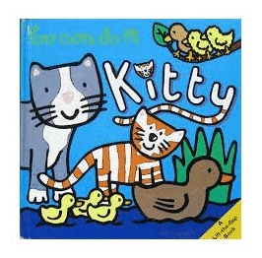  This week we will be thinking about Perseverance – We will be learning what it means to persevere so that we can keep going even when something is really tricky!  We will also be continuing to learn about how to look after our classroom and each other.  Our behaviour expectation for this week is Do work hard. | We will be listening to stories, rhymes and fairy tales.    We will also be starting Poetry Basket, this is a special rhyme and movement activity we do during our morning sessions. It is great fun and features a range of seasonal and classic poems.  Chop Chop  Chop, Chop, Choppity Chop.    Cut off the bottom and cut off the top.  What there is left, we put in the pot.  Chop, Chop, Choppity Chop. | Our theme for the term is ‘This is Me’.  Our aim is that all children feel happy, safe and welcome in Crickets. Each child is individual and their learning journey is unique.  This week we will be talking about ourselves and families and getting to know each other!  This all fits in with the school ethos of Being the Best That We Can Be.  We will begin to teach children how to self-regulate and understand their feelings.  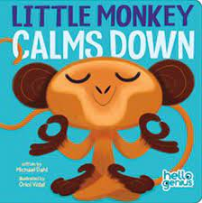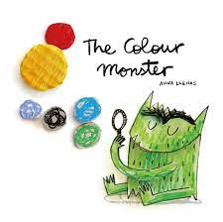
This week our Number Rhyme is 10 Fat Sausages   | We will be playing “What’s Time Mr Wolf?”  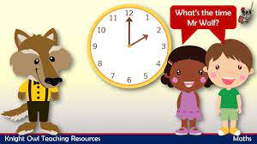  We will be singing the Nursery Rhyme ‘Row Row your Boat’. 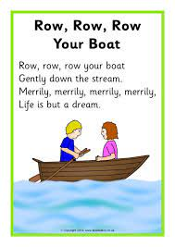 | We will be starting our mark making journey by making different marks outside using big arm movements.  